CloudWatch Metrics
Amazon CloudWatch Metrics allow you to monitor AWS resources and applications in real time by collecting, storing, and analyzing performance data.

Key Concepts of CloudWatch Metrics
- Namespace: A container for CloudWatch metrics (e.g., AWS/EC2, AWS/RDS).
- Metrics: Data points for resources (e.g., CPUUtilization, DiskReadOps).
- Dimensions: Attributes for filtering metrics (e.g., InstanceId, DatabaseInstanceIdentifier).
- Time Periods: Metrics are collected at 1-minute (standard) or 1-second (high-resolution).
- Statistics: Aggregate data like Average, Sum, Min, Max, Percentiles.

Examples of AWS CloudWatch Metrics by Service
AWS Service | Common CloudWatch Metrics
EC2 | CPUUtilization, NetworkIn, DiskReadBytes
RDS | FreeableMemory, DatabaseConnections, ReadIOPS
EBS | VolumeReadOps, VolumeWriteOps, BurstBalance
S3 | BucketSizeBytes, NumberOfObjects, 4xxErrors
Lambda | Invocations, Duration, Errors, Throttles
ElastiCache | CacheHitRate, CurrConnections, Evictions
CloudFront | Requests, BytesDownloaded, TotalErrorRate

Scenario: Monitoring an EC2 Instance
💡 Problem: You want to monitor an EC2 instance to check CPU usage and set an alarm if CPU usage goes above 80% for 5 minutes.
✅ Solution:
- Go to CloudWatch Console → Metrics
- Select Namespace: AWS/EC2
- Choose the CPUUtilization metric for your instance
- Click Create Alarm
- Set Threshold to > 80% for 5 minutes
- Configure an SNS Notification to get alerts via email/SMS
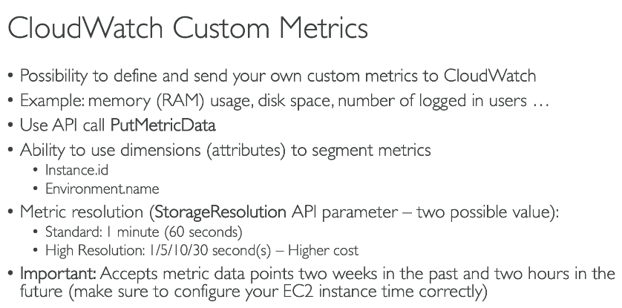
Scenario:
You have a web application running on an EC2 instance. You want to track the number of active users and send this metric to CloudWatch every minute.
Step 1: Create an IAM Role (For EC2 or Lambda)
To allow publishing metrics, create an IAM Role with the following permissions:
- Attach the policy CloudWatchFullAccess to an IAM role.
- Attach this role to the EC2 instance (if running from EC2).

Step 2: Install AWS SDK (If Not Installed)
If you're using Python, install the AWS SDK (Boto3):

Step 3: Write a Python Script to Publish Metrics
Create a script (publish_metric.py) to send the ActiveUsers metric to CloudWatch:

Step 4: Run the Script
Execute the script on your EC2 instance or locally:
This will continuously send the ActiveUsers metric to CloudWatch every minute.

Step 5: View the Custom Metric in CloudWatch
- Go to AWS CloudWatch Console
- Navigate to Metrics → Select Custom Namespace (MyApplication).
- Select ActiveUsers and view the graph.
- You can also create CloudWatch Alarms based on this metric (e.g., if active users exceed 400).

CloudWatch Dashboards
Amazon CloudWatch Dashboards provide a centralized view of AWS resources and application performance by displaying metrics, logs, and alarms in a visual format.

Key Features of CloudWatch Dashboards
✅ Multi-Resource Monitoring – View data from EC2, RDS, Lambda, S3, and more in a single place.
✅ Customizable Widgets – Add graphs, numbers, text, and alarms for better visualization.
✅ Real-time & Historical Data – Monitor metrics over different time ranges.
✅ Cross-Region Support – View AWS resources across multiple regions in one dashboard.
✅ Sharing & Access Control – Restrict access using IAM policies.

Scenario: Create a CloudWatch Dashboard for EC2 & RDS Monitoring

Objective:
Monitor EC2 instance CPU utilization and RDS free memory in one dashboard.

Steps to Create a CloudWatch Dashboard
1️Go to AWS CloudWatch Console
2️Click on Dashboards in the left panel.
3️Click Create Dashboard → Enter a name (e.g., MyApp-Monitoring).
4️Choose Add Widget → Select Graph Widget.
5️Choose EC2 Metrics → Select CPUUtilization → Choose instance ID.
6️Click Add Widget again → Choose RDS Metrics.
7️Select FreeableMemory → Choose the database instance.
8️Click Create Dashboard to save the changes.
9️(Optional) Set Alarms: Click a widget → Set a CloudWatch Alarm (e.g., CPU > 80%).

CloudWatch Logs Overview
Amazon CloudWatch Logs is a service that collects, monitors, and stores logs from AWS resources, applications, and services in real-time.

Key Features of CloudWatch Logs
✅ Centralized Logging – Collect logs from EC2, Lambda, RDS, CloudTrail, and more.
✅ Log Retention & Storage – Store logs for analysis and compliance.
✅ Real-time Monitoring & Alerts – Set alarms on specific log patterns.
✅ Log Insights – Use SQL-like queries for log analysis.
✅ Integration with AWS Services – Works with Lambda, SNS, S3, and more.

Scenario: Monitoring EC2 Logs in CloudWatch Logs
Objective:
Collect Apache web server logs from an EC2 instance and store them in CloudWatch Logs.
Steps to Set Up CloudWatch Logs for EC2
1️Go to the CloudWatch Console
2️Click Logs → Log Groups → Create Log Group (e.g., /ec2/apache-logs).
3️Install the CloudWatch Agent on the EC2 instance.
4️Configure the agent to collect logs from /var/log/httpd/access.log.
5️Start the agent → Logs will be sent to the CloudWatch Log Group.
6️Go to CloudWatch Logs Insights → Query logs to analyze traffic patterns.
7️Set up CloudWatch Alarms for error logs (e.g., status 500 errors).

CloudWatch Log Insights – Querying Logs
Example SQL-like query to find the most common HTTP status codes in Apache logs:
Sql
fields @timestamp, @message
| parse @message "* - - [*] \"* * *\" * *" as ip, time, method, path, status, size
| stats count(*) by status
| sort count(*) desc

Amazon CloudWatch Alarms – Overview
CloudWatch Alarms help you monitor AWS resources and automatically take action when a metric crosses a threshold. You can trigger SNS notifications, auto-scaling, Lambda functions, or even stop an instance based on conditions.

Key Features of CloudWatch Alarms
✅ Monitor AWS Services – EC2, RDS, S3, Lambda, ELB, etc.
✅ Trigger Actions – Send SNS alerts, execute Lambda, or adjust Auto Scaling.
✅ Threshold-Based Alerts – Set conditions like CPU > 80% for 5 minutes.
✅ Multiple Evaluation Periods – Define how long the condition must persist.
✅ Different States – OK, ALARM, INSUFFICIENT_DATA.

Scenario: Monitor EC2 CPU Usage and Send an Alert
Objective:
Set an alarm to notify via SNS when an EC2 instance's CPU usage exceeds 80% for 5 minutes.
Steps to Create CloudWatch Alarm
1️Go to the AWS CloudWatch Console
2️Click Alarms → Create Alarm
3️Select Metric Source → Click EC2 Metrics → Select CPUUtilization for your instance
4️Set Threshold:
- Condition: Greater than 80%
- Period: 5 minutes
- Evaluation Periods: 1
5️Set Actions:
- Send Notification to SNS Topic (Create one if not available)
- Example: High-CPU-Usage-Alerts
6️Name the Alarm (e.g., EC2-High-CPU)
7️Click Create Alarm
🚀 Now, when CPU usage crosses 80% for 5 minutes, an SNS alert is triggered!

CloudWatch Synthetics – Overview
Amazon CloudWatch Synthetics helps you monitor application endpoints by running automated tests (Canaries) to detect performance issues, broken links, or API failures before your users do.

Key Features of CloudWatch Synthetics
✅ Simulates user interactions – Monitors API endpoints, websites, and workflows.
✅ Detects failures before users notice – Alerts for downtime or slow responses.
✅ Uses Canaries (Automated Scripts) – Runs tests every few minutes.
✅ Captures logs, screenshots, and traces – Helps with debugging.
✅ Integration with CloudWatch Alarms & Logs – Get alerts when failures occur.

Scenario: Monitor Website Availability
Objective:
You have a customer-facing website (https://example.com) and want to ensure it’s always up. If the website goes down, you need to get an alert.
Steps to Create a CloudWatch Synthetics Canary
1️Go to AWS CloudWatch Console
2️Click Synthetics → Create Canary
3️Choose a Blueprint
- Select "Heartbeat Monitoring" (checks if a website is reachable)
4️Define Canary Settings
- Name: Website-Health-Check
- URL: https://example.com
- Frequency: Every 1 minute
- Run Time: 24x7 Monitoring
5️Select Storage and Execution Role
- Create an S3 bucket to store test results
- Assign an IAM Role with permissions
6️Enable CloudWatch Alarms
- Set up an alarm to trigger if the website is down for 2 minutes
7️Click Create 🚀
✅ Result:
- CloudWatch Canaries will ping your website every minute
- If the site goes down, you get an SNS alert
- You can check logs, screenshots, and response times in CloudWatch Logs
Amazon EventBridge – Overview
Amazon EventBridge is a serverless event bus that allows AWS services, custom applications, and third-party SaaS apps to communicate in real time. It helps trigger actions automatically when an event occurs, without needing constant polling.

Key Features of EventBridge
✅ Event-driven architecture – Automatically routes events based on rules.
✅ Supports AWS & custom events – Works with AWS services, SaaS apps, and your own applications.
✅ Serverless & scalable – No infrastructure management.
✅ Event filtering – Only relevant events are passed to the target.
✅ Reliable & Secure – Uses AWS IAM for access control and encrypts data.
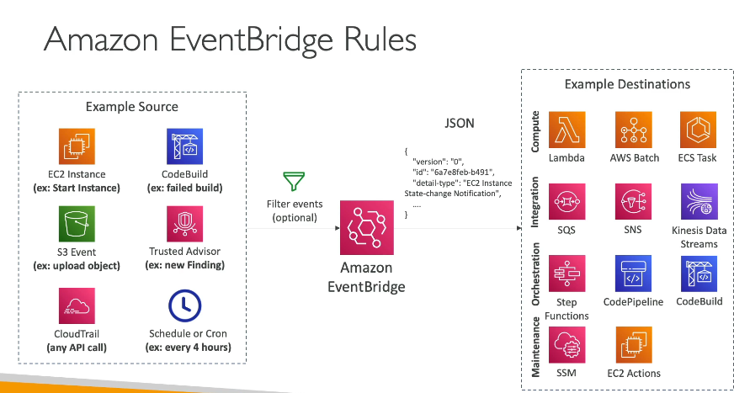

Scenario: Trigger Lambda When an EC2 Instance Starts
Objective:
You want to run a Lambda function whenever a new EC2 instance starts. This function will send a notification or update a database.
Steps to Set Up EventBridge Rule
1️Go to AWS Console → Open Amazon EventBridge
2️Click Rules → Create Rule
3️Define Rule Details
- Name: EC2-Instance-Start-Trigger
- Event Bus: default
4️Select Event Source
- Event Source: AWS Services
- Service: EC2
- Event Type: EC2 Instance State-change Notification
- Specific State: running
5️Choose Target
- Target: AWS Lambda function (Select your function)
6️Set Permissions
- Ensure EventBridge has permission to invoke the Lambda function
7️ Review & Create Rule
✅ Result:
- When an EC2 instance starts, EventBridge triggers the Lambda function
- The Lambda function logs the event or sends an SNS notification
- No need for constant polling!

✅ Service Quotas (formerly AWS Limits)
Service Quotas in AWS are limits or boundaries set by AWS on how much of a particular resource or service you can use. These limits are often soft limits, which means you can request an increase.

🎯 Why Service Quotas Are Important?
- Prevent accidental overuse of resources.
- Helps in cost control and capacity planning.
- Ensures AWS resources are used efficiently and securely.
- Allows tracking and requesting quota increases directly from the AWS Console.

🧠 Types of Quotas
Quota Type | Example
Service Limit (Soft) | Max 5 Elastic IPs per Region
Hard Limit (Fixed) | Max 1 default VPC per Region
Resource-specific Limit | Max 50 EC2 instances per Region
Rate Limit (API calls) | Max API requests per second

📌 Real-Life Scenario
Scenario:
You’re launching a new application and need to spin up 100 EC2 instances.
But AWS only allows 20 EC2 instances per Region by default.
✅ Steps to Request a Quota Increase:
- Go to AWS Console → Open Service Quotas
- Select the service (e.g., EC2)
- Find the quota you want to increase (e.g., Running On-Demand Standard (A, C, D, H, I, M, R, T, Z) instances)
- Click Request Quota Increase
- Enter desired limit (e.g., 100)
- Add justification (brief reason)
- Click Submit Request
📝 AWS Support will review the request and usually respond within a few hours to a day.

🔍 Monitoring Quotas
You can use:
- AWS CloudWatch to set alarms on quota usage
- Service Quotas Dashboard for visual tracking
- Budgets + Quotas to control and predict costs

💡 Bonus Tip
You can also use the AWS CLI or Service Quotas API to automate quota checks or increase requests in your infrastructure as code (IaC) setups.
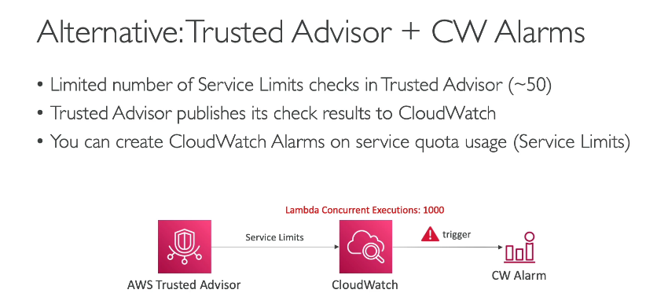

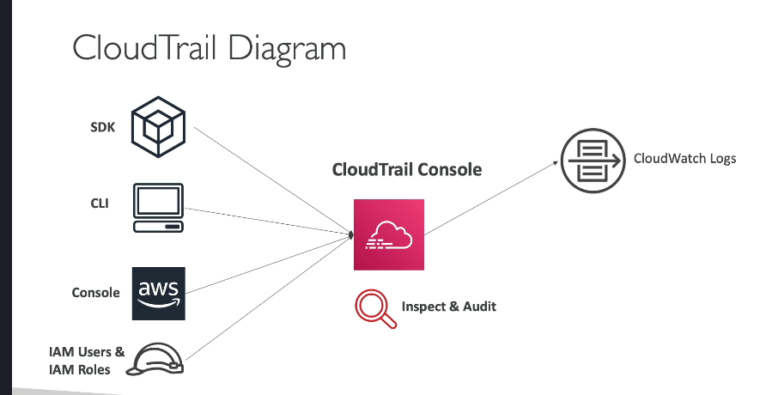

Amazon CloudTrail – Explained with Examples & Scenarios
Amazon CloudTrail is an AWS service that helps you track user activity and API usage across your AWS infrastructure. It provides event history of your AWS account activity, including actions taken through the AWS Console, SDKs, CLI, and other services.

🔍 Why is CloudTrail Important?
- Security & Compliance: Helps meet auditing requirements.
- Operational Troubleshooting: Identify who made changes to resources.
- Forensics: Investigate suspicious activity.
- Governance: Ensure proper access and usage across your AWS account.

📘 Key Features
Feature |  |  |  |  |  |  | Description
Event History |  |  |  |  |  |  | View last 90 days of events in the AWS console
Trails |  |  |  |  |  |  | Set up trails to record events in all or specific regions
Log to S3 |  |  |  |  |  |  | Store logs for long-term auditing and analysis
Integration with CloudWatch Logs |  |  |  |  |  |  | Real-time monitoring of API activity
Insights (optional) |  |  |  |  |  |  | Detect unusual activity patterns

🧠 Types of Events
- Management Events:
  - Track changes to resources like EC2, IAM, S3 (e.g., RunInstances, CreateUser)
- Data Events:
  - Track object-level operations in S3 or Lambda (e.g., GetObject, PutObject)
- Insights Events (Optional):
  - Detect unusual activity like sudden spikes in API calls

🧪 Scenario-Based Example
Scenario:
Your team is managing an EC2 instance that suddenly terminates. You want to know who did it and when.
How CloudTrail Helps:
- Go to CloudTrail > Event history
- Search for event name: TerminateInstances
- Filter by Resource name or Instance ID
- You’ll see:
  - Time of action
  - IAM user or role who performed the action
  - Source IP
  - Region
  - Request & response details
🎯 This makes it easy to audit and trace changes in your environment.

✅ Steps to Create a CloudTrail Trail
- Go to AWS Console > CloudTrail
- Click Create trail
- Name your trail (e.g., organization-activity-trail)
- Choose to Apply to all regions
- Select S3 bucket to store logs (create or choose existing)
- (Optional) Enable CloudWatch Logs integration
- Enable Log file validation (for tamper detection)
- Click Create trail
🔐 Security Best Practices
- Enable CloudTrail for all regions
- Log data events for critical resources like S3, Lambda
- Enable log file validation
- Store logs in encrypted S3 buckets
- Monitor with CloudWatch Alarms

🧰 Useful Integrations
- Amazon Athena: Run SQL-like queries on CloudTrail logs
- Amazon GuardDuty: Uses CloudTrail logs for threat detection
- AWS Config: Tracks configuration changes; CloudTrail shows who made them
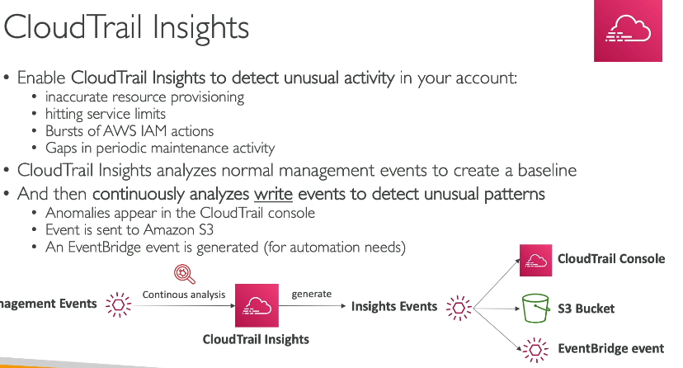
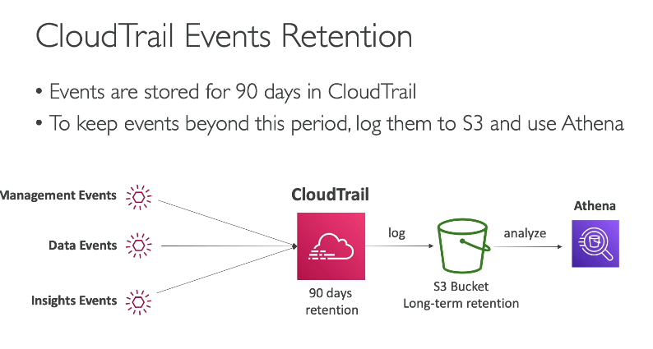
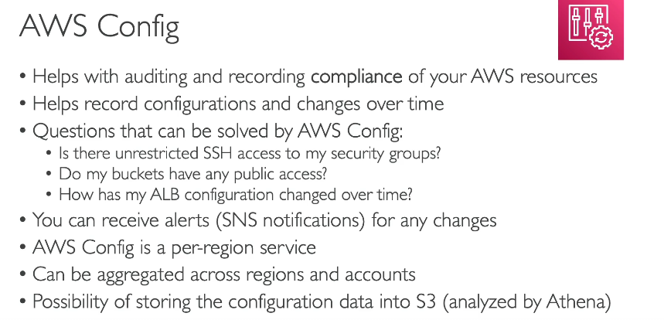

AWS Config – Explained with Simple Scenario-Based Understanding
AWS Config is a service that tracks and records resource configurations in your AWS account and helps you audit, evaluate, and monitor changes over time.

🧠 What Does AWS Config Do?
Feature |  |  |  |  |  |  | What it Means
Tracks Configuration |  |  |  |  |  |  | Records the configuration of supported AWS resources
Change Detection |  |  |  |  |  |  | Shows how and when configurations change
Compliance Checks |  |  |  |  |  |  | Evaluates resource configurations against defined rules
Historical View |  |  |  |  |  |  | View previous states of your resources
Snapshot & Timeline |  |  |  |  |  |  | Visualizes changes over time for auditing and troubleshooting

📘 Real-Life Scenario to Understand
🧪 Scenario:
You’re managing EC2 instances. Someone changed a security group rule to allow SSH (port 22) from 0.0.0.0/0. You want to find out:
- When it was changed
- Who changed it
- Was it compliant with your rules?

How AWS Config Helps:
- Go to AWS Config Dashboard
- Search for the EC2 security group
- View its configuration timeline
- Identify the change event (port opened)
- Check if a compliance rule (e.g., "No open SSH") was violated
- View the user or service who made the change (linked to CloudTrail)

🔍 Key Concepts
Concept |  |  |  |  |  |  |  |  |  |  | Description
Configuration Item |  |  |  |  |  |  |  |  |  |  | A snapshot of a resource’s configuration
Configuration History |  |  |  |  |  |  |  |  |  |  | A record of all config changes over time
Configuration Timeline |  |  |  |  |  |  |  |  |  |  | A visual history of changes to a resource
Rules |  |  |  |  |  |  |  |  |  |  | Custom or managed policies to check compliance
Remediation |  |  |  |  |  |  |  |  |  |  | Automatic action triggered on non-compliance

✅ Steps to Set Up AWS Config
- Go to AWS Console → Config
- Click Set up AWS Config
- Choose:
  - Region or all regions
  - S3 bucket to store configuration history
  - IAM Role (auto-created if needed)
- Select resources to record (or choose all supported)
- Optionally, enable AWS Config Rules (e.g., required tags, open ports)
- Review and click Confirm
🔐 Security/Compliance Example
Rule Name |  |  |  |  |  |  |  | What it Checks
restricted-ssh |  |  |  |  |  |  |  | Disallows public SSH access
required-tags |  |  |  |  |  |  |  | Ensures resources have mandatory tags
ec2-instance-no-public-ip |  |  |  |  |  |  |  | Ensures EC2s don’t have public IPs
s3-bucket-public-read-prohibited |  |  |  |  |  |  |  | Blocks S3 buckets from being publicly readable

📊 How AWS Config Works with Other Services
- 📝 CloudTrail → Shows who made the changes
- 📦 S3 → Stores config snapshots and compliance history
- 📈 CloudWatch → Trigger alerts when resources become non-compliant
- ⚙️ Systems Manager (SSM) → Can run remediation actions

📁 Example Use Case
Use Case: Ensure all EC2 instances are tagged with Environment=Production
- Create AWS Config Rule: required-tags
- Specify the required tag: Environment=Production
- AWS Config checks all EC2s
- Non-compliant resources are listed
- Optionally, trigger Lambda to send a warning or tag automatically

Simple flow using a real-world scenario so you understand how AWS Config, CloudWatch, and EventBridge work together — like a monitoring and automation team!
🧪 Scenario-Based Example:
"You want to make sure no EC2 instance should be launched without the Environment tag. If someone launches an EC2 without this tag:
🔔 You should be notified, and
🔧 AWS should automatically tag it as Environment=Dev."
Let’s see how each service plays a role 👇

🔁 Flow of Services Working Together
🧩 1. AWS Config: The Rule Checker
- You create a Config Rule: required-tags
- This rule checks every EC2 instance to see if it has Environment tag
- If an instance is missing the tag, it becomes non-compliant
✅ Config = Watchdog that continuously evaluates resource configurations

📢 2. EventBridge: The Event Router
- AWS Config sends an event to EventBridge when a resource becomes non-compliant
- You create an EventBridge Rule:
🔹 Event pattern: "Non-compliant with required-tags rule"
🔹 Target: A Lambda function to fix it automatically
✅ EventBridge = Traffic cop that routes the event to a response

🔧 3. Lambda (Optional): The Auto-Fixer
- The Lambda gets the EC2 instance ID from the event
- It adds the missing tag → Environment=Dev
✅ Lambda = Auto-mechanic that applies a fix

📈 4. CloudWatch: The Notifier
- You create a CloudWatch Alarm or Log Metric Filter
- It listens to Config Logs or EventBridge events
- If the rule is triggered often, it sends an SNS notification (email/SMS)
✅ CloudWatch = Alert system for logs and metrics

In Summary (Simple Table):
Service | Role in the Flow
AWS Config | Checks resource for compliance (e.g., missing tags)
EventBridge | Detects non-compliance event and triggers actions
Lambda | (Optional) Fixes the issue (e.g., adds missing tag)
CloudWatch | Notifies you with alarms/logs if non-compliance happens
Goal: You want to get notified instantly if someone deletes an EC2 instance (by mistake or on purpose) 😨

🛠️ Step-by-Step Flow:
1️CloudTrail - Records the Action
- A user runs:
bash
CopyEdit
aws ec2 terminate-instances --instance-ids i-1234567890abcdef
- CloudTrail captures it like:
User himanshu@yourorg.com called TerminateInstances API on EC2 at 5:30 PM
✅ CloudTrail acts like a CCTV camera recording every API call made in your AWS account.

2 EventBridge - Detects the Event
- You configure EventBridge to listen for specific CloudTrail events.
- You create a rule like:
IF eventName = TerminateInstances AND resourceType = EC2, THEN trigger action
✅ EventBridge is like a smart security guard who watches the camera and acts instantly.

3️CloudWatch / Lambda - Takes Action
You choose what EventBridge should do. For example:
Option | Action Triggered
CloudWatch Alarm | Sends alert to email/SNS/Slack
Lambda Function | Automatically re-creates the EC2 instance
SNS Notification | Sends SMS/email to the team

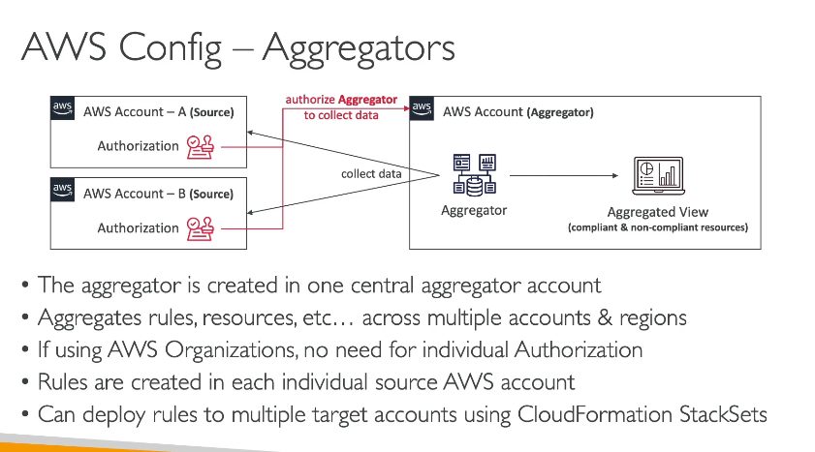

CloudWatch, CloudTrail, and AWS Config in simple terms with comparison table + scenario examples so it's easy to understand and remember.
🔍 Overview
Feature | CloudWatch | CloudTrail | AWS Config
Purpose | Monitor metrics, logs, alarms, events | Track user activities & API calls | Record resource configurations & changes
Focus | Performance + Operational Health | Security + Auditing | Compliance + Resource state history
Time-based | Real-time / near real-time | Near real-time | Periodic snapshots or on changes

🧠 Simple Definitions
- CloudWatch = "How is my application/infrastructure performing?"
- CloudTrail = "Who did what in my AWS account?"
- AWS Config = "What is the state of my AWS resources, and how did they change over time?"

💡 Scenario Examples
📊 CloudWatch
- You want to monitor CPU usage of an EC2 instance.
- You want to trigger an alarm when an RDS DB exceeds 80% storage.
- You want to visualize logs from your Lambda function.
🕵️‍♂️ CloudTrail
- You want to see who terminated an EC2 instance.
- You need to audit user actions in your account for compliance.
- You're investigating a security incident.
🧾 AWS Config
- You want to know when a security group was modified to allow open access.
- You want to ensure all resources have proper tags.
- You want a history of all config changes on an S3 bucket.

✅ Comparison Summary Table
Feature |  | CloudWatch |  |  | CloudTrail |  |  | AWS Config
Monitors |  | Metrics, Logs, Events |  |  | API calls (who did what) |  |  | Resource configuration & changes
Use Case |  | Performance, Alerts |  |  | Auditing, Security, Investigations |  |  | Compliance, Configuration History
Stores data in |  | CloudWatch Logs |  |  | S3 (by default) |  |  | S3 (config snapshots)
Real-time support |  | Yes |  |  | Near real-time |  |  | No (delayed or snapshot-based)
Data retention |  | Custom (logs/metrics) |  |  | 90 days (default), longer with S3 |  |  | Long-term in S3
Integrates with |  | Alarms, Dashboards |  |  | CloudWatch, Lambda, SNS |  |  | CloudTrail, Lambda, CloudWatch

🧪 All Three in One Real-Life Scenario
You’re managing a web app hosted on EC2 with S3, RDS, and IAM.
- CloudWatch: Alerts you when EC2 CPU is high or RDS connections are maxed out.
- CloudTrail: Shows that a user deleted an S3 bucket.
- AWS Config: Lets you view the bucket’s config before it was deleted and confirms if it was compliant with tagging or encryption rules.
CloudWatch Logs Metric Filter allows you to search logs for specific patterns, such as the keyword "Error." Once the Metric Filter identifies occurrences, it can trigger a CloudWatch Alarm, enabling automated, real-time monitoring of the logs for errors, aligning with AWS monitoring best practices.
Unified CloudWatch Agent is required to push memory usage and other system-level metrics to CloudWatch, as EC2 does not send memory usage metrics to CloudWatch by default. This ensures comprehensive monitoring of EC2 instances.

"AWS Config Remediations" is correct because this feature allows AWS Config to automatically take corrective actions, such as reconfiguring Security Groups, to ensure resources maintain compliance with defined rules, like restricting unauthorized SSH access.

"Use CloudTrail Log File Integrity Validation" is correct because this feature provides cryptographic proof to ensure that CloudTrail logs stored in S3 have not been altered or deleted, maintaining the integrity and reliability of your log data for auditing and compliance purposes.

